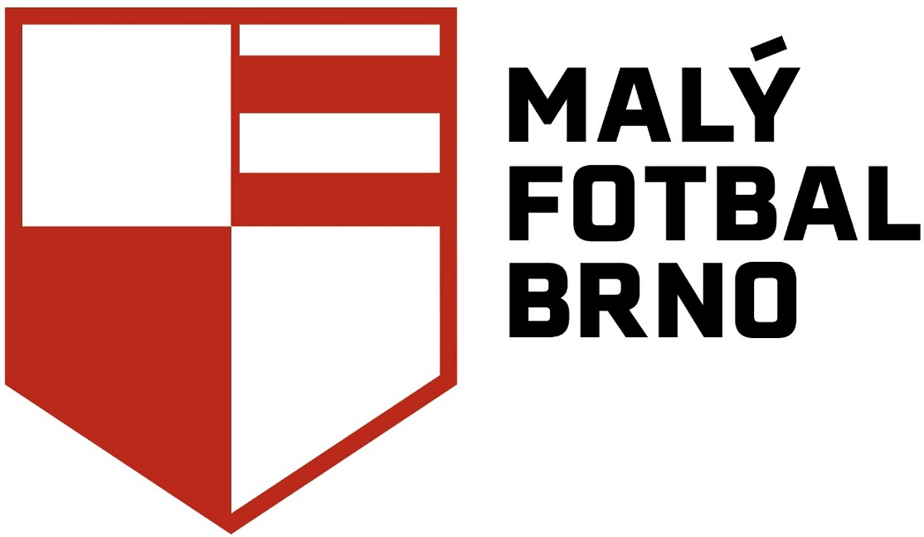 MEMBERSHIP APPLICATION TO THE REGIONAL  ASSOCIATION OF MINIFOOTBALL IN THE CZECH REPUBLIC, r. a.
________________________________________________________________________

Regional association*: Malý fotbal Brno, z.s. ID number*: 266 42 441

First name and surname*: Registration number:
(to be filled by the association)

Club name*: Place of birth*:

Date of birth*: Personal identification number*:

Permanent residence*:
(street, house number, ZIP code, town/city)

Secondary residence:
(street, house number, ZIP code, town/city) Nationality:*

Phone number*: E - mail*:

Social network name: Sex (male/female):
(Facebook, Twitter, or other
and profile name)
Job:
* Mandatory fields

I, the undersigned, honestly declare that I perform in the above-mentioned regional association (hereinafter referred to as the “RA”) registered with the Association of Minifootball in the Czech Republic, r.a. (hereinafter referred to as the “AMF CR”) at my own risk and I am fully responsible for my state of health. I solemnly declare that I will not make any financial or other claims against the RA or the AMF CR in case of any health or other problems related to my health condition during my performance in the RA. I aknowledge that I join the RA and subsequently the AMF CR voluntarily and I agree with my registration in the above-mentioned RA.

By signing below, I declare that I acknowledge and fully agree with the text of the document "Information on Personal Data Processing and Consent to Personal Data Processing", which I have received together with this application.

I declare that I have read the text of this application carefully, I understand its contents and I agree with it.
I confirm the above-said by my handwritten signature.

Date: Club president signature:

New member signature: Legal representative signature
(for players under the age of 18):

Regional association representative signature:

Annexes: !!! 1 original and undamaged photograph in the size of an identity card, the registration fee for the purpose of making the player's registration and the membership fee form a necessary part of the member's application. The amount of both fees is specified by the Tariff of fees and remuneration, which is available on the website of the above-mentioned regional association !!!

